Applying for Charitable Support Checklist
(do not include this checklist with your application packet)

Thank you for applying with Tulalip Cares on behalf of your 501(c)(3) status organization or government/school. The Tulalip Tribes community impact funds are committed to improving arts and culture, education and youth, the environment, health care, public safety, and social services in our communities.

Reminder: Fund distributions are made four times a year. Application and attachments for them are due March 1, June 1, September 1, and December 1 of each year and must be postmarked on or before the due date.

Please find document labels on page 7. Print and attach them to each of your documents and use this checklist to help ensure your application packet is complete and provided in desired order.

- Charitable Fund Grant Application. Found on pages 3 and 4 and should be the first document in your application packet. It must be filled out completely including signature.

- Proposal Summary. Summarize in a short paragraph the purpose of your organization. Briefly describe why a grant is requested, what outcomes you hope to achieve, and how funds would be spent if a grant is made.

- Narrative. The narrative should include:

- Some background describing the work of your organization. Give the needs or problems that your organization works to address, and the population served including geographic location, socio-economic status, race, ethnicity, gender, and age group. List current programs and accomplishments and the number of paid full-time, part-time, and volunteer staff. Describe your organization’s relationships—both formal and informal—with other organizations working to meet the same needs or providing similar services and explain how you differ from these other organizations.
- Your funding request. If applying for general operating support, briefly describe how this grant would be used. If your request is for a specific project, please explain its primary purpose and the need or problem that you are seeking to address. Give the names and titles of the individuals who will direct the project. Include the anticipated length of the project and how it contributes to your organization’s overall mission.
- An evaluation of how you will measure the effectiveness of your activities. Describe your criteria for a successful program and the results you expect to have achieved by the end of the funding period.

- Financial Statement(s). This can be audited financial statements to a copy of the most recent bank statement, depending on the size of the charity. This statement should reflect actual expenditures and funds received.

- Operating Expenses. A report specific to the project.

- Current Funding Sources. List other sources and amounts that are already secured for your project.

- Solicited Funding Sources. List other foundations you are currently seeking support from.

- Board/Commissioner and Affiliations. A list of your Board of Directors, Council, Commissioners or Officers with their affiliations. This adds credibility to your project, as we want adequate oversight with credible community members.

- IRS Letter with 501 (c)(3) or Government/School Designation. Submit a copy of the letter from the Internal Revenue Service where the designation of 501 (c)(3) status for your organization is mentioned. If not available, provide an explanation, such as Federally recognized Tribe, Educational Institution, etc.

- Key Staff/Volunteers. One paragraph resumes of key staff/volunteers, including qualifications relevant to the specific request.

- Annual Report (optional). To show capability to fulfill other similar projects and run an efficient organization.

To save paper, please print multi-page documents double sided if possible. Please note that submitted materials, pictures, and documents will not be returned.

Mail completed application packet (which must be postmarked on or before the due date) to:

Tulalip Tribes Charitable Fund
8802 27th Ave NE
Tulalip, WA 98271

If your application packet is approved and funds received, we would appreciate a follow-up report upon the completion of your project for posting to our website. Please email along with pictures to msheldon@tulaliptribes-nsn.gov.

ALL FIELDS ARE REQUIRED TO
CONSIDERED FOR REVIEW

CONFIDENTIAL

Legal name of organization  Click or tap here to enter text. |  | Employer Identification Number (EIN)  Click or tap here to enter text.
Physical Address
Click or tap here to enter text.

City  Click or tap here to enter text. | State  WA |  | Zip Code (+4)  Click or tap here to enter text.
Mailing Address
Click or tap here to enter text.

City  Click or tap here to enter text. | State  WA |  | Zip Code (+4)  Click or tap here to enter text.
Chief Executive Officer (CEO) or President  Click or tap here to enter text. | Contact person for this application (if different than CEO/President  Click or tap here to enter text.
If name is different than the name listed on the IRS exemption letter, please explain relationship to exempt organization:  Click or tap here to enter text. | Contact person’s title  Click or tap here to enter text.
Contact person’s telephone number
Click or tap here to enter text.
Organization’s main or CEO/President telephone  Click or tap here to enter text. | Contact person’s e-mail address  Click or tap here to enter text.
CEO/President e-mail address  Click or tap here to enter text. | Organization’s website address  Click or tap here to enter text.
Principal purpose and service of your organization  Click or tap here to enter text. | Number of employees  Click or tap here to enter text.
Number of volunteers
Click or tap here to enter text.
Approximate number of persons served annually
Click or tap here to enter text.
Geographic area served.  Click or tap here to enter text. | Age range of persons served  Click or tap here to enter text.

ALL FIELDS ARE REQUIRED TO
CONSIDERED FOR REEVIEW

CONFIDENTIAL

Organization’s annual months of operation |  | Organization’s weekly days of operation | Times
☐ Year-round  ☐ January  ☐ February  ☐ March  ☐ April  ☐ May  ☐ June  ☐ July  ☐ August  ☐ September  ☐ October  ☐ November  ☐ December |  | ☐ Monday Through Friday: | Click or tap here to enter text.
 |  | ☐ Mondays | Click or tap here to enter text.
 |  | ☐ Tuesdays | Click or tap here to enter text.
 |  | ☐ Wednesdays | Click or tap here to enter text.
 |  | ☐ Thursdays | Click or tap here to enter text.
 |  | ☐ Fridays | Click or tap here to enter text.
 |  | ☐ Saturdays | Click or tap here to enter text.
 |  | ☐ Sundays | Click or tap here to enter text.
Specific purpose for which funds are requested
Click or tap here to enter text.

Amount requested  $Click or tap here to enter text. |  | Period of time in which funds will be spent.  From: Click or tap to enter a date. | To: Click or tap to enter a date.
☐ Yes ☐ No | Does your organization receive support from the United Way or other federated funds?  If yes, attach a list of which ones.
☐ Yes ☐ No | Does your organization have 501(c)(3) status?  If yes, include a copy of IRS letter stating your organization’s non-profit status (with label #9, IRS Letter). If no, include the name of sponsoring organization with your organization name at top.
Signature date |  | CEO/President or Representative’s signature

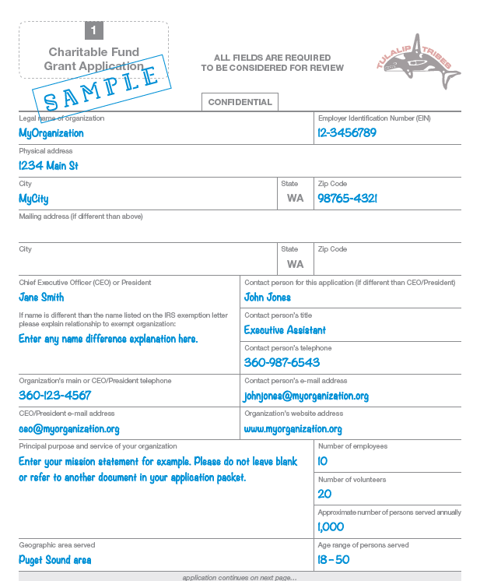
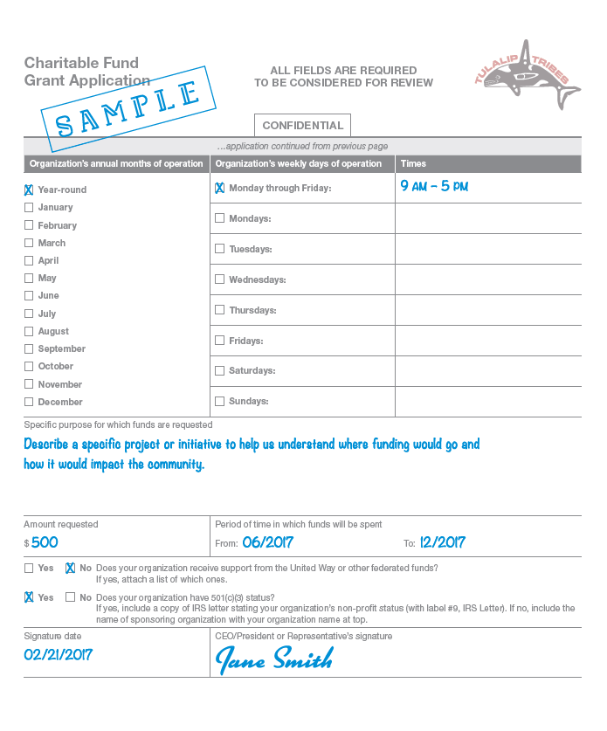

Document Labels

Please attach the labels below to the top of each of the documents in your application packet. They can
be printed upon Avery® label stock 5160 or hand cut and applied (document #1 Charitable Fund Grant
Application already includes its label preprinted at top).

